Creating branch and Deleting Branch

# Tasks:

1. Create a remote repository on GitHub.

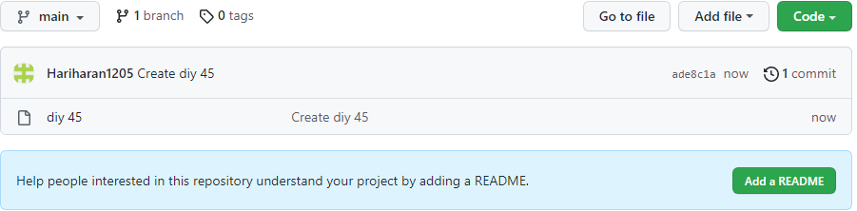

1. Add a file in the main branch in the GitHub repo

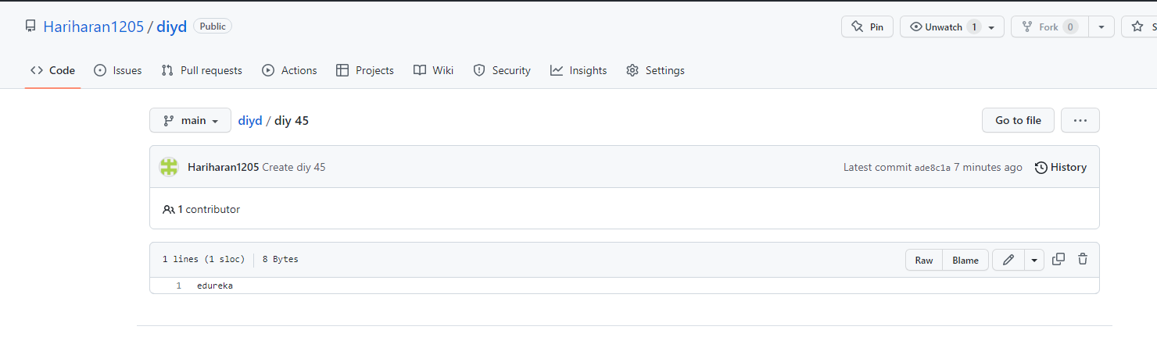

1. Clone the repository to the local server

Command: git clone https://github.com/Hariharan1205/hari.git

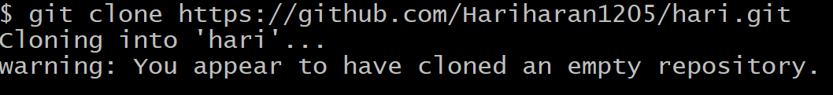

1. Create a new branch with a name feature

Command: git branch feature

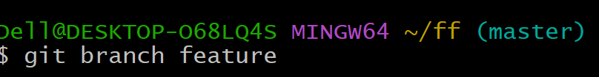

1. Checkout out the branch feature

Command: git checkout feature

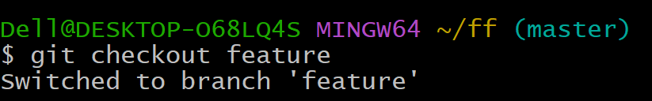

1. Add a new file to the branch feature

Command: touch edu



1. Push the branch to the remote repository

Command: git push origin feature

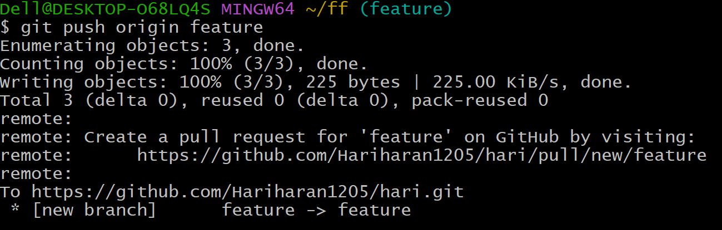

1. Create a pull request in Github and merge the feature branch with the main branch.



1. Delete the feature branch in the remote repository

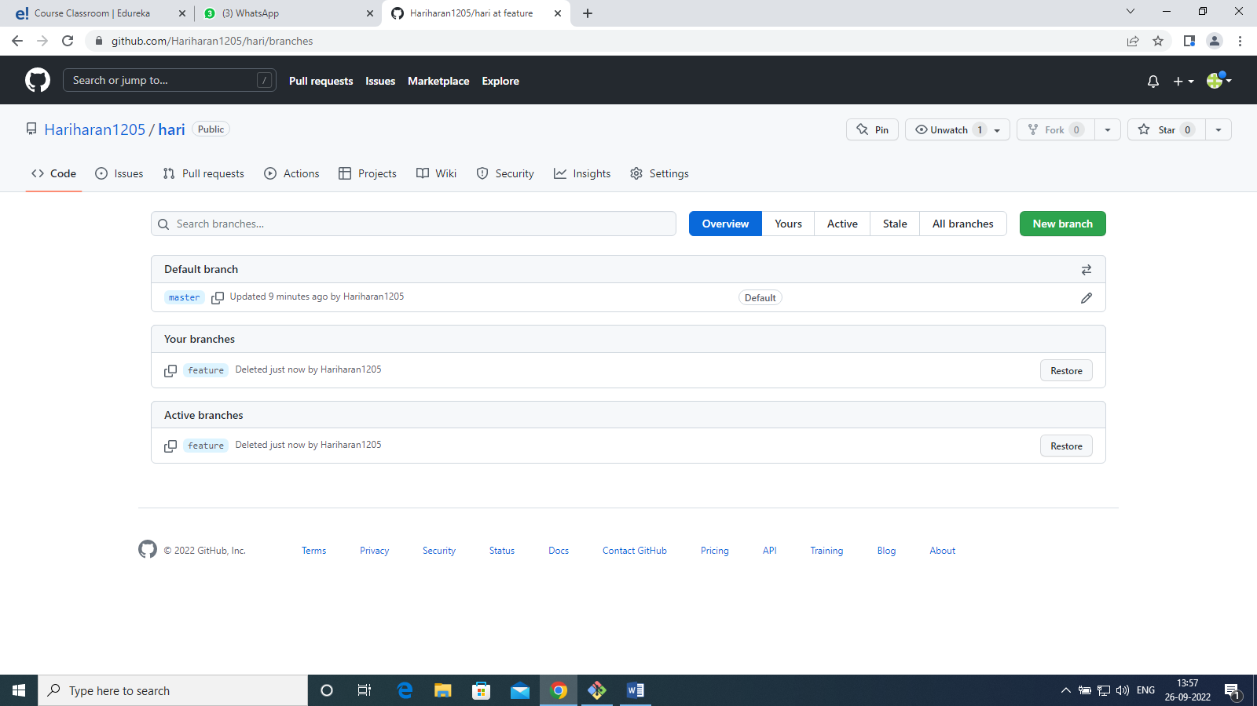

1. Delete the feature branch on local repository

Command: git branch –D feature

